****JINJA JOINT EXAMINATIONS BOARD**

**MOCK EXAMINATIONS 2022**

**P425/2 MATHEMATICS**

**MARKING GUIDE**

1. T1 T2 = 2T1  **B1**

d

A B

20N 16N

(T) : T1 + 2T1 = 36 **M1**

T1 = 12 **B1**

T2 = 24

M(A) : 20 x 2 + 16 x d = 24 x 4 **M1**

d = 3.5m **A1**

**05**

1. P(P $∩$ Q) = $P\left(P\right)×P\left(Q/P \right)$**B1**

= 0.6 x 0.9

= 0.54

P Q

0.06 0.54 0.26 **B1**

0.14

1. P (P or Q but not both P and Q) = 0.06 + 0.26

= 0.32 **A1**

1. P(P(Q) = $\frac{P(P∩Q)}{P(Q)}$

= $\frac{0.54 }{0.8}$**M1**

= $\frac{54}{80}$**A1**

**05**

1. (a) $\frac{20-15}{13.6 -12} = \frac{20 -D}{13.6 -12.8}$**B1** **M1**

$D = 17.5$**A1**

(b) $\frac{34.7 -31}{F- 12}$ = $\frac{31 - 25}{5.0 - 10.5}$**MI**

$F=16.08\overline{3}$**A1**

**05**

1. (a)

VR ${60 ms}^{-1}$

$θ$ ${135}^{0}$

$100{ms}^{-1}$

$V_{R}^{2} = {100}^{2} + {60}^{2}-2×60×100×cos{135}^{0}$

$V_{R }=148.6112 {ms}^{-1}$

(b) $\frac{148.6112}{\sin{{135}^{0}}} = \frac{60}{sinθ}$

$θ = {16.6}^{0}$**B1**

$∴$ Direction is $N 73. 4^{0}E$**A1 05**



$P =0.46, q=0.54, n=100$

$μ =np=100 ×0.46 σ= \sqrt{100 ×0.46 ×0.54}$

$= =4.98397$**B1**

$P\left(X <50\right)=P(Y <49.5)$**B1**

$P \left(\frac{Z <49.5-46}{4.98397}\right)$**M1**

$P (Z <0.702)$

$0.5+0.2586$**M1**

$=0.7586$**A1**

**05**

1. $h= \frac{\frac{π}{3}-0}{4} = \frac{π}{12}$**B1**

**B1**

**B1**

|  |  |  |
| --- | --- | --- |
| $$x$$ | $$y_{0} , y_{4}$$ | $$y_{1}, ……y_{3}$$ |
| 0 | 1.000 |  |
| $$\frac{π}{12}$$ |  | 1.255 |
| $$\frac{π}{4}$$ |  | 1.462 |
| $$\frac{π}{3}$$ | 1.425 | 1.551 |
| Sum | 2.425 |  |
|  |  | 4.268 |

$\int_{0}^{\frac{π}{3}}{e^{x}\cos{x dx =\frac{1}{2}× \frac{π}{12 }× \left[2.425 ×2 (4.268)\right]}}$**M1**

$$=1.434$$

$1.43 (3s.f)$**A1**

**05**



**B1**

**B1**

|  |  |  |  |  |  |  |  |  |
| --- | --- | --- | --- | --- | --- | --- | --- | --- |
| $$Rx$$ | 3 | 6 | 7 | 1 | 8 | 4.5 | 2 | 4.5 |
| $$Ry$$ | 2 | 5 | 6 | 1 | 8 | 7 | 4 | 3 |
| $$d$$ | 1 | 1 | 1 | 0 | 0 | -2.5 | -2 | 1.5 |

$\sum{d^{2} =15.5}$**B1**

$r_{s} = 1- \frac{6×15.5}{8 ×63}$**M1**

$= 0.8155$**A1**

**05**



$v= e^{t}i+2e^{-2t}i-\sin{tk}$

$a= e^{t}i- {4e}^{-2t}j-cosk$**M1**

$∴force, F=2 \left(e^{t}i-4e^{-2t}j-costk\right)$

$= {2e}^{t}i- {8e}^{-2t}j-costk$**B1**

Power = $F . V$

$= \left(\begin{matrix}{2e}^{t} \\ {-8e}^{-2t} \\ -2cost\end{matrix}\right) . \left(\begin{matrix}e^{t} \\ {2e}^{-2t} \\ -sint\end{matrix}\right)$

$= {2e}^{2t}+ -{16e}^{-4t}+sin2t$**M1**

When $t=4;$ power = ${2e}^{2t}- {16e}^{-4(4)}+sin2 (4)$**M1**

$=5961.92 units$**A1**

**05**

1. (a) $μ =52 , σ =16$
2. $P \left(X <40\right) = P \left(Z < \frac{40-52}{16}\right)$**M1**

$=P(Z < -0.75)$

$=0.5-0.2734$

$=0.2266$**B1**

$∴$ Number of candidates in the school $= \frac{20}{0.2266}$**M1**

$=88.2613$**A1**

1. $P \left(X ≥68\right) = P \left(Z ≥ \frac{68-52}{16}\right)$**M1**

$=P (Z ≥1.000)$

$= 0.5-0.3413$

$=0.1587$**B1**

$∴$ Number who got distinctions.

$=0.1587 ×88.2613$**M1**

$=14.0071$**A1**

(b) $S.E = \frac{16}{\sqrt{16}} =4$**B1**

**M1 M1**

$∴ \left(46 < \overline{X} <58\right) = P\left(\frac{46-52}{4} <Z < \frac{58-52}{4}\right)$

$=P (-1.5 <Z <1.5)$

$=2 ×0.4332$

$=0.8664$**A1**

**12**

1. (a) y

$u$

P ($x , y )$

$x$

$∝$ y

O $x$

If the particle is projected with speed $u,$ at an angle $∝$ to the horizontal, then,

$\dot{x}=u\cos{∝ ------ }$ (1) **B1**

$\dot{y}=u sin∝ -gt----$ (2) **B1**

$⟹ x=u cos∝t----$ (3) **B1**

$y=usin∝t-\frac{1}{2} gt^{2}---$ (4) **B1**

Substituting (3) into (4) for t,

$y=u sin∝ \left(\frac{x}{ucos ∝}\right)$ $- \frac{{gx}^{2}}{{2u}^{2}\cos^{2}∝}$**M1**

$y=xtan ∝ - \frac{{gx}^{2}}{{2u}^{2}} \left(1+tan∝\right)$**B1**

(b) $y=9 , x=72$

(i) using $y=xtan∝ - \frac{{gx}^{2}}{{2u}^{2}} \left(1+tan∝\right)$

$9=72 tan∝ - \frac{ 10 {\left(72\right)}^{2} }{2{\left(30\right)}^{2}} - \left(1+tan∝\right)$**M1**

$16\tan^{2}∝ -40 tan∝ +21=0$**B1**

$tan∝ = \frac{40 ±16}{32}$**M1**

$\frac{56}{32} or \frac{24}{32}$

$∴tan∝ = \frac{3}{4} or \frac{7}{4}$

$⟹ ∝ =36.9^{0} and {60.2}^{0}$**M1 A1 A1**

**12**

1. (a) (i)

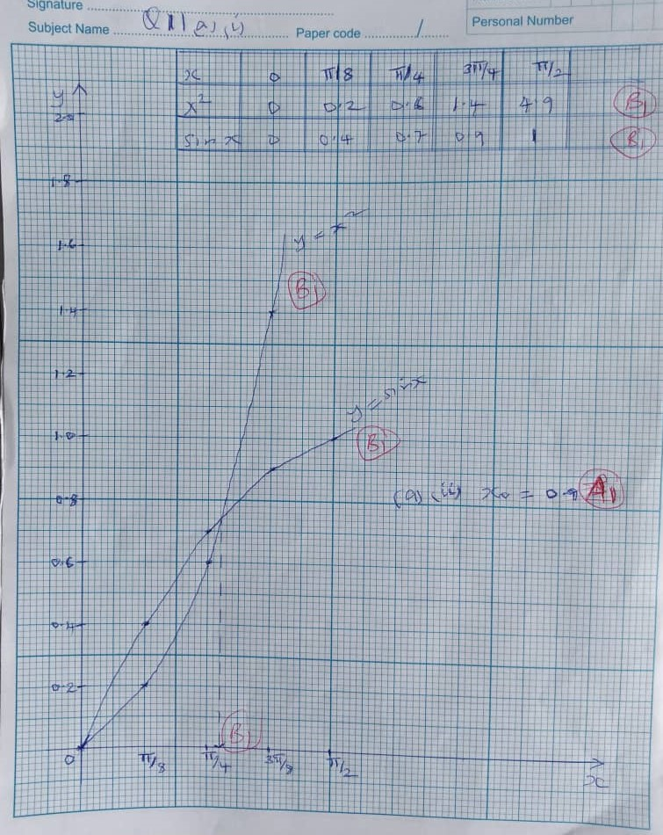

1. (ii) $x_{0} =0.9$**A1**

(b) $f\left(x\right)= x^{2}-\sin{x}$

$f\left(x\right)=2x-cosx$**M1**

$x_{1}=0.9- \frac{\left({0.9}^{2}-\sin{0.9}\right)}{2\left(0.9\right)-\cos{0.9}}$**M1**

$=0.8774 e_{1} =0.0226$**B1**

$x_{2} =0.8774- \frac{\left({0.8774}^{2}- \sin{0.8774}\right)}{2 \left(0.8774\right)-\cos\left(0.8774\right)}$**M1**

$=0.8767 e_{2} =0.0007$**B1**

$∴root=0.877$**A1**

**12**



$V_{t} = \int{\left(e^{-2t} i-2cost j+4sin2t k\right) dt}$

$= \frac{-1}{2} e^{-2t}i-2 sint j-2\cos{2t k +C}$**M1**

$V_{t}=0=i=2j+4k$

$⟹i-2j+4k= \frac{-1}{2}e^{-2\left(0\right)}i-2sin0j-2cos2\left(0\right)k+C$**M1**

$C= \frac{3}{2} i-2j+6k$**B1**

$∴ V_{t }= \left(\begin{matrix}\frac{-1}{2} e^{-2t} & + \frac{3}{2} \\ -2sint & - 2 \\ -2cos2t & + 6\end{matrix}\right)$**A1**

1. $V_{t}= \frac{π}{2} = \left(\begin{matrix}\frac{-1}{2} e^{-π} & + & \frac{3}{2} \\ -2sin\frac{π}{2} & - & 2 \\ -2cosπ & + & 6\end{matrix}\right)$**B**

$\left(\begin{matrix}1.4784 \\ -4 \\ 8\end{matrix}\right)$

Speed $= \sqrt{{\left(1.4784\right)}^{2}+ {\left(-4\right)}^{2}+ 8^{2}}$**M1**

$=9.06563$**A1**



$r_{t} = \int{\left(\frac{-1}{2} e^{-2t}+3\right) i- \left(2+ 2sint\right) j+(6-2cos2t}) k dt$

$= \left(\frac{1}{4} e^{-2t}+ \frac{3}{2} t\right)i - \left(2t+2cost\right) j+\left(6t-4sin2t\right)k+C_{1}$**M1**

$when t=0$;

$2i-j+4k=\frac{1}{4}i-2i+0k+C_{1}$**M1**

${C }_{1}=\frac{7}{4} i+j+4k$**B1**

$∴r_{t}=\left(\frac{1}{4} e^{-2t}+ \frac{3}{2}t +\frac{7}{4}\right) i+\left(2t+2cost+1\right)i+(6t-2sin2t+4)k$**M1 A1**

**12**

1. (a)

|  |  |  |  |  |  |
| --- | --- | --- | --- | --- | --- |
| Height | *f* | X | Xf | $$X^{2}f$$ | *f.d* |
| 147 – 156 | 12 | 151. 5 | 1818 | 275427 | 1.2 |
| 157 – 161 | 8 | 154 | 1272 | 202248 | 1.6 |
| 162 – 166 | 8 | 164 | 1312 | 215168 | 1.6 |
| 167 – 171 | 9 | 169 | 1521 | 257049 | 1.8 |
| 172 – 176 | 7 | 174 | 1218 | 211932 | 1.4 |
| 177 – 186 | 6 | 181.5 | 1089 | 197653.5 | 0.6 |
| Sum | 50 |  | 8230 | 1,359,477.5 |  |

**B1 B1 B1**

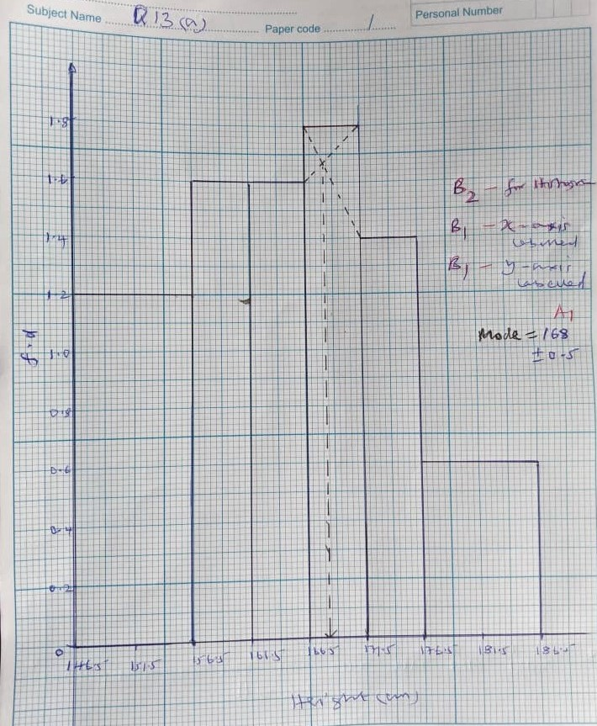

1. (i) Mean height = $\frac{8230}{50}$**M1**

= 164.6 **A1**

(ii) Standard deviation = ${\left[\frac{1,359,477.5}{50 } - {\left(164.6\right)}^{2}\right]}^{\frac{1}{2}}$**M1**

= 9.8178 **A1**

**12**

1. (a) $\frac{∆l}{L} ×100=5$ $\frac{∆w}{w} ×100=4.2$

$∆L= \frac{5 ×5.25}{100}$ $∆w = \frac{4.2 ×0.44}{100}$

$=0.0625$**B1** = 0.01848 **B1**

A max $=\left(1.25+0.0625\right)×(0.44+0.01848)$**M1**

= 0.602

= 0.60 **A1**

A min = $\left(1.25-0.0625\right)×(0.44-0.01848)$**M1**

= 0.500 **M1**

= 0.50 **A1**

(b) $e= \frac{A^{2} }{ B}- \frac{a^{2}}{b}$**M1**

$= \frac{{\left(a+ e_{1}\right)}^{2}}{\left(b+ e_{2}\right)} - \frac{a^{2}}{b}$

$= \frac{b \left(a^{2}+2ae_{1}+ e_{1}^{2 } \right)- a^{2} (b+ e_{2})}{b ( b+ e_{2})}$

= $\frac{2abe_{1} + e_{1}^{2} b- a^{2} e_{2}}{b (b+ e_{2})}$

$= \frac{2abe_{1}+ e_{1}^{2}b- a^{2} e_{2}}{b^{2} (1+ \frac{e_{2}}{b})}$

If $\left|e_{1}\right| <<< \left|A\right| and \left|e_{2}\right| <<< \left|B\right|$**B1**

$\frac{e_{2}}{b} ≈0 and e_{1}^{2} ≈0$

$∴e = \frac{2 a b e_{1}- a^{2} e_{2}}{b^{2}}$

$= \frac{a^{2}}{b} \left[\frac{2e_{1}}{a} - \frac{e_{2}}{b}\right]$

$\left|e\right| ≤ \frac{a^{2}}{b} \left[\left|\frac{2e_{1}}{a} \right|+ \left|\frac{e_{2}}{b}\right|\right]$**M1** **B1**

$erel = \frac{\left|e\right|}{\left|\frac{a^{2}}{b}\right|} ≤ \frac{a^{2}}{b} × \frac{b}{a^{2}} \left[\left|\frac{2e_{1}}{a}\right|+ \left|\frac{e_{2}}{b}\right|\right]$**M1**

$\left(erel\right) max=2 \left|\frac{e_{1}}{a}\right|+ \left|\frac{e_{2}}{b}\right|$**B1**

**12**

1. (a)

y

k y = k **B1**

$$y=kx$$

$B1$

0 4 $x$**B1** for axes

(b) (i) $\frac{1}{2} ×1 ×k +3k=1$**M1**

$K=\frac{2}{7}$**A1**

(ii) $E\left(x\right) = \int_{0}^{1}{x.\frac{2}{7} xdx+ \int_{1}^{4}{x.\frac{2}{7} dx}}$

$= \frac{2}{21} {\left[x^{3}\right]}_{0}^{1}+\frac{1}{7} {\left[x^{2}\right]}_{1}^{4}$**M1**

$=\frac{2}{21}+\frac{1}{7}\left(16-1\right)$**M1**

$= \frac{47}{25} or 2.2381$**A1**



$\int_{0}^{1}{\frac{2}{7} xdx =\frac{1}{7} {\left[x^{2}\right]}_{0}^{1}}$

$=\frac{1}{7} <\frac{1}{2}$**B1**

$∴median= \frac{1}{7} + \int_{1}^{m}{ \frac{2}{7} dx=\frac{1}{7}}$

$⟹\frac{2}{7} {\left[x\right]}_{1}^{m}=\frac{5}{4}$**M1**

$⟹ \frac{2}{7} \left[m-1\right] =\frac{5}{4}$**M1**

$m = \frac{9}{4} or 2.25$**A1**

**12**

1. 20N
2. R

300

2g **B1**

250

( ) : **M1**

**B1**

( ) : **M1**

$f_{r}=5.4372 N$**B1**

$∴coeff. of friction, μ= \frac{f_{r}}{R}= \frac{5.4372}{7.7636}$**M1**

$=0.7$**A1**

1. R

$f_{r}$

**B1**

${25}^{0}$ $2g$

( ) : $R=2g cos{25}^{0}$**M1**

$=2 ×9.8 cos{25}^{0}$

$=17.7636 N$

$F_{max} = μR$**M1**

$=0.7 ×17.7636 =12. 435N$**B1**

Particle will remain at rest if the friction force is large enough to balance the component of its weight down the plane.

Component weight $=2 ×9.8 ×cos{65}^{0}$

$=8. 2833 N$**M1**

Since $F_{max} >8.28 N,$ particle will remain at rest. **B1**

**12**

**E N D**